# introduction

Dear candidate,

Thank for taking our Dr. Panda programming test!

Please review the project you have received together with this document. You need Unity3d 5.1.3p2 or greater to open it. When completing our test, you will have to code in C# only, and you are free to use any third party plugin or framework which helps you to achieve the end goal.

Your work will be checked against possible bugs or performance issues. Please, make sure that the code provided by you is **well structured**, **clean**, and **easy to read**. Your technical solution will be rated depending on its **simplicity** and **maintainability**. Besides that, please, pay attention to **the visual details** to make the game as easy and appealing as possible. It will also influence the final result of our decision.

Good luck!

Dr. Panda

# Simple trash game concept

In the trash game players have to sort trash to the correct containers, plastic to plastic, glass to glass etc. The camera’s projection should be set to orthographic. Trash should use physics but their collider shapes don't need to be 100% accurate.

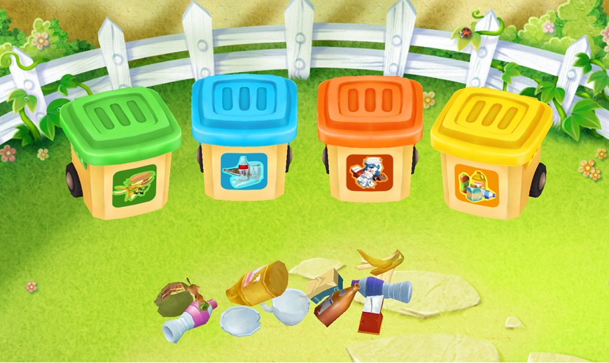

## Intro

During the intro players should not be able to touch anything

* The 4 containers drive into the screen from the right
* The trash drops a short distance onto the ground
* When the containers are in place they should rotate into their correct position
* After that the containers will open and close 1 time

## Playing

From here players should be able to start using things

* Only 1 piece of trash can be dragged at a time
* While dragging the trash pieces, pieces should push away other pieces of trash if you drag them over each other
* Pieces of trash should never leave the screen
* When you start dragging a piece of trash, the correct container should open
* If a piece is over a container and you release your finger, the piece of trash should jump into the container, after the piece is inside the container, the container should close
* If a piece is not over a container and you release your finger, the piece should drop to the ground and the correct container should close

## End

* After all pieces are in the container, stars should fall from the top of the screen for 3 seconds

# Sounds

These are the .OGG files that will need to play in the game:

10_General_pickup an item – when you pick up a piece of trash

13_General_magicsound – at the end when the stars start to fall

76_Recycling_OpenBin – when a container opens

77_Recycling_CloseBin – when a container closes

77A_Recycling_Trashbinmoving – while the containers are driving into the screen

75_Recycling_TrashintheBin food – when a piece of food is dropped into the food container

75_Recycling_TrashintheBin plastics – when a piece of plastic is dropped into the plastics container

75_Recycling_TrashintheBin paper – when a piece of paper is dropped into the paper container

75_Recycling_TrashintheBin glass – when a piece of glass is dropped into the glass container